# University of Central Florida Enhances Classroom Audio with Sennheiser TeamConnect Ceiling 2 Technology

The TeamConnect Ceiling 2, Installed in Conference Rooms and Classrooms Across Campus, Provides Flexible and Scalable Audio Solutions for Modern Learning at UCF

**Bloomington, IL — May 5, 2025 —**[**Sennheiser**](http://www.sennheiser.com/)**, the first choice for advanced audio technology that makes collaboration and learning easier, is proud to announce that the University of Central Florida (UCF) completed a successful installation of its** [**TeamConnect Ceiling 2**](https://www.sennheiser.com/en-us/catalog/products/meeting-and-conference-systems/teamconnect-ceiling-2/teamconnect-ceiling-2-black-509161) **(TCC 2) throughout a variety of conference rooms, combinable classrooms, and high profile spaces including a large conference room in Millican Hall on the university’s main campus. UCF chose Sennheiser's TCC 2 for its advanced audio technology, seeking to enhance clarity and intelligibility during lectures and discussions. This deployment was part of an update to existing systems to improve the audio experience for students and faculty, supporting effective communication and collaboration in UCF’s modern learning environments.**

UCF sought a solution to address the challenges of providing clear and consistent audio in large, dynamic spaces. Traditional microphone setups, involving numerous devices strewn across tables and a significant wireless footprint, proved costly and difficult to deploy. Sennheiser's TCC 2 offers a streamlined solution via its ceiling-mounted, beamforming technology, effectively covering large areas without the need for extensive hardware. This is particularly crucial for UCF's high-profile, reconfigurable spaces, which host a constant flow of students, educators, and visitors that require flexible audio solutions. The ability to maintain a clean, uncluttered presentation environment while ensuring exceptional audio quality was a key factor in selecting the TCC 2. Further, the TCC 2 can be controlled via the existing Crestron control system UCF has deployed in each room.

Sennheiser's award-winning TCC 2 award is an optimal audio solution for large meeting spaces, offering unparalleled speech intelligibility and flexible room configuration. Its patented automatic dynamic beamforming and TruVoicelift technology, coupled with 28 German-made electret condenser capsules, ensure crystal-clear audio capture. Designed for seamless integration, the TCC 2 provides Dante and analog output options, PoE support, and certifications for major platforms like Microsoft Teams and Zoom. Advanced features such as Exclusion and Priority Zones, along with camera control via talker position data, further enhance its functionality, all within a sleek, modern design that prioritizes both performance and aesthetic integration.

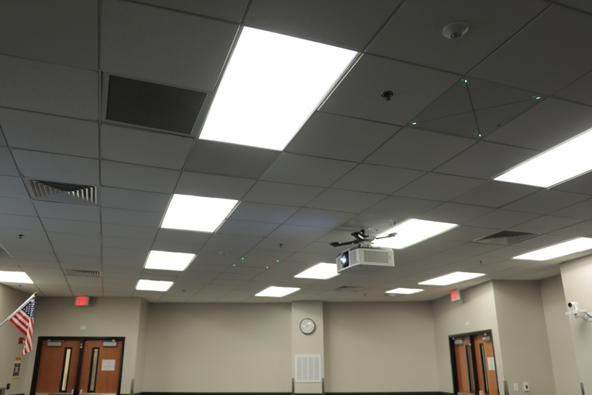

“The true success of an AV system is when it goes unnoticed,” said Mike Ferry,

assistant director of instructional technology with UCF’s Office of Instructional Resources. “The TeamConnect Ceiling 2 delivers flawless audio and the product is discreet — nearly invisible — allowing users to focus on the meeting and not the technology. When meetings start and the audio is perfect, that's when you know the system is doing its job. The feedback surrounding the installation, ease-of-use, and clarity of audio where we have it installed on campus has been resoundingly exceptional.”

To learn more about TCC 2, visit <https://www.sennheiser.com/en-us/catalog/products/meeting-and-conference-systems/teamconnect-ceiling-2/teamconnect-ceiling-2-black-509161>.

###

**About the Sennheiser brand**

We live and breathe audio. We are driven by the passion to create audio solutions that make a difference. Building the future of audio and bringing remarkable sound experiences to our customers – this is what the Sennheiser brand has represented for more than 75 years. While professional audio solutions such as microphones, meeting solutions, streaming technologies and monitoring systems are part of the business of Sennheiser electronic GmbH & Co. KG, the business with consumer devices such as headphones, soundbars and speech-enhanced hearables is operated by Sonova Holding AG under the license of Sennheiser.

[www.sennheiser.com](http://www.sennheiser.com)

[www.sennheiser-hearing.com](http://www.sennheiser-hearing.com)

**Global Press Contact**

Jeff Horan

[jeffrey.horan@sennheiser.com](mailto:jeffrey.horan@sennheiser.com)

+1 860-598-7539